- Open your Git Bash shell.
- Check git version
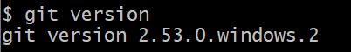
- Check the configuration
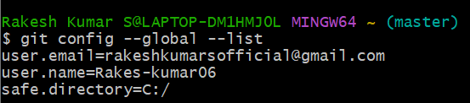
- Check for notepad++
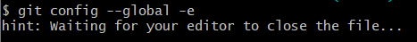
- Create a new project repository named "GitDemo"
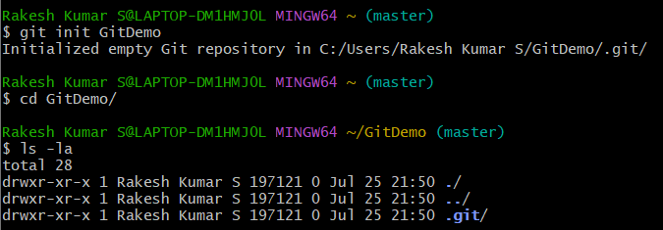

- Create a file named "welcome.txt" and add content to it
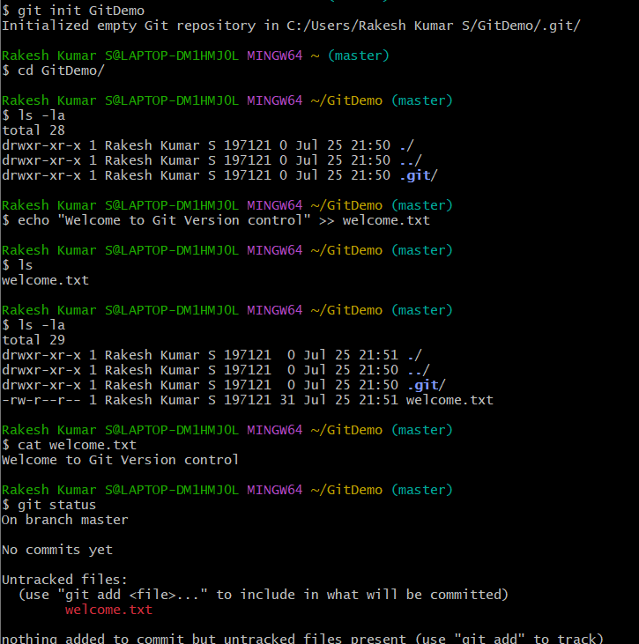
- Make the file tracked by Git:
